Introduction
Four weeks waiting for samples from a custom clothing manufacturer. The box finally lands at the warehouse. Inside, the hoodies are wrinkled, two sizes off, and two shades darker than the Pantone swatch you sent. The neck labels sit crooked, and the embroidery pulls the whole front panel out of shape.
That kind of mess is not bad luck. It usually comes from skipping the hard work up front: no clear production model, no real check on factory expertise, no agreement on sampling or quality standards. In apparel manufacturing, guesswork turns into chargebacks, angry customers, and piles of dead stock fast.
This guide gives you a straight, practical way to choose a manufacturer before you send money or designs. You will get clear on what you actually need, score factories against five weighted pillars, understand what a real sampling and quality control process looks like, and see how to build a partnership that can grow with your brand. No fluff, just a framework you can use on your next factory shortlist.
“Price is what you pay. Value is what you get.” – Warren Buffett
In sourcing, value comes from reliability, not the lowest quote on a spreadsheet.

Know What You Need Before You Start Searching
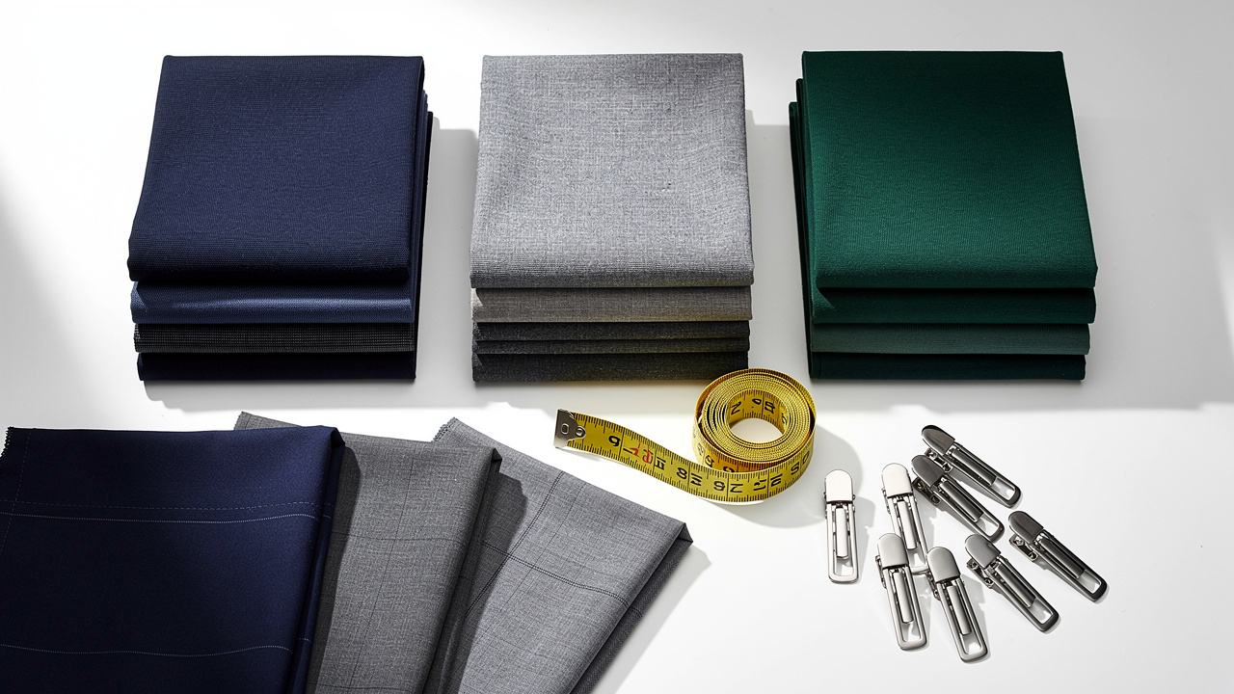
Most brands start by blasting the same message to twenty factories asking for price and MOQ. The answers come back all over the place, and everyone looks “kind of fine” on paper. The real issue is simple: you have not decided what type of production model fits your stage, so the whole search is blurry.
In apparel manufacturing — a sector shaped by rapidly shifting Key Trends in U.S. production models — there are three main ways to work with a factory. If you mix them up, you set up both sides for frustration. Here is the simple breakdown.
Model | What It Means | Best For
CMT (Cut, Make, Trim) | You bring fabrics, trims, and a detailed tech pack, and the factory cuts, sews, and finishes. | Brands with solid design teams and existing fabric suppliers.
Full Package (OEM or ODM) | The factory sources materials, manages production, and delivers finished garments from your tech pack or concept. | Brands that want one partner to handle most of the work.
Private Label | The factory offers ready styles and you add your branding and light customization. | Brands that care about speed and lower upfront risk.
If you ask a pure CMT shop to handle fabric sourcing and design, you will get delay after delay. If you ask a private label program for fully custom patterns, you will get a polite no or a quote that never makes sense.
Run through this quick self-check before you message another custom clothing manufacturer:
- Tech Pack Or Concept: Do you have a full tech pack, or just a sketch and mood board? Be honest here. If you only have sketches, you need development help. That pushes you toward full package OEM or ODM, not basic CMT.
- Fabric And Trim Sourcing: Do you need help with fabric sourcing, or do you already have mills and trim vendors you trust? If you do not, write that down. A good factory can source for you, but not every plant offers that service. Sharing this early avoids long email chains later.
- Realistic First Order Quantity: What is your realistic first order quantity: under two hundred units, around three hundred, or five hundred and above? Put the real number on paper. That number filters out factories whose minimums will stretch your cash. It also keeps you from overcommitting on your first run.
- Speed Versus Differentiation: Is speed to market or brand differentiation more important for this launch? If speed wins, private label or light customization makes sense. If your focus is fit, fabric, and specific design details, you are in OEM or ODM territory, and that always takes a bit more time.
- Design Support Needs: Do you need design support, or only production execution? If you want pattern tweaks, fit advice, and tech pack building, you should say that in your opening email. If you just need someone to sew exact specs, you can focus on execution-first factories and talk mainly about capacity and price.
Your answers tell you which type of custom clothing manufacturer to approach. Asking the wrong factory for the wrong model is one of the fastest ways to burn weeks and lose trust.
As one senior production manager put it, “Factories are not magic. If you give them a blurred brief, you get a blurred result.”

The Five-Pillar Evaluation Framework
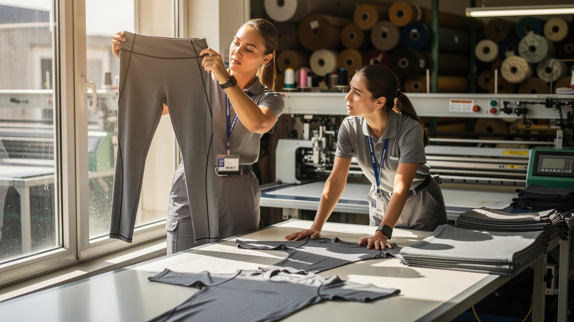
Once you know your model, you need a way to compare factories without going by gut feel or the lowest quote. A simple scoring system keeps you grounded. Think of it as a scorecard where each pillar gets a weight. You can score each factory from one to ten on every pillar, apply the weights, and see who actually fits.
Here is the framework.
Pillar | Weight | What to Evaluate
Expertise Match | 30% | Their main product types, factory equipment, and past work in your category.
Compliance And Ethics | 25% | Fabric and process certifications like OEKO-TEX and GOTS, plus social audits.
Communication | 20% | Response time, clarity, and whether you get a stable contact person.
Lead Times | 15% | Realistic sample timing around fifteen business days, and bulk timing of thirty to sixty days.
Scalability | 10% | MOQ flexibility now and capacity to handle larger orders as your brand grows.
Expertise match is simple but often ignored — and with the Global Advanced Apparel Manufacturing market growing increasingly specialized, aligning with a factory that genuinely lives in your product category has never mattered more. If you are building compression leggings, you want a custom clothing manufacturer that lives in performance knits, not one that mostly makes woven shirts. Ask for recent samples and factory photos that match your level of detail, not just glossy catalog pictures.
Compliance and ethics are about more than comfort. OEKO-TEX testing helps protect you when you sell into the US or EU, because fabrics are checked for harmful substances. If you claim organic or low impact in your branding, GOTS certification on cotton and processes backs that up with real standards, not just nice words.
Communication sounds soft, but it shows you how the factory runs. If it takes four days to answer a simple fabric question, imagine how they will handle a real production issue. You want clear, simple language about problems, not excuses or silence.
Lead times must match your calendar, not your dream calendar. Ask for best case and normal case, and how they handle peak seasons. Scalability is about whether that same partner can take you from a one hundred unit test run to several thousand units across styles without falling apart or changing price stories midstream.
A simple way to use the framework:
- List your shortlisted factories in a spreadsheet.
- Score each pillar from 1–10 for every factory.
- Multiply each pillar score by its weight.
- Add the weighted scores to get a total out of 100 for each factory.
This gives you a calm, structured view when quotes and promises start to blur together.

Why Compliance and Communication Get More Weight Than Price
Price is the one number everyone chases, but it is the easiest one to fake. A factory that cuts corners on compliance can buy cheaper fabrics with hidden chemicals and push them into your line. That looks fine until customs, platforms, or customers start asking hard questions.
If sustainability sits anywhere in your marketing, GOTS and similar standards matter, because they connect your claims to real audits. Compliance is not just a badge; it protects your brand when regulations shift or new markets open.
Communication matters just as much. A partner who tells you about delays early gives you options, such as shifting colors or staggering drops. A plant that ghosts you during sampling will do the same during bulk. The cheapest factory on paper is rarely the cheapest once you add rework, refunds, wasted time, and damaged reputation.
“Trust is built with consistency.” – Lincoln Chafee
A factory that communicates clearly during the quote stage is far more likely to communicate clearly when something goes wrong on the line.

Sampling and QC — What Actually Happens (and What Should)
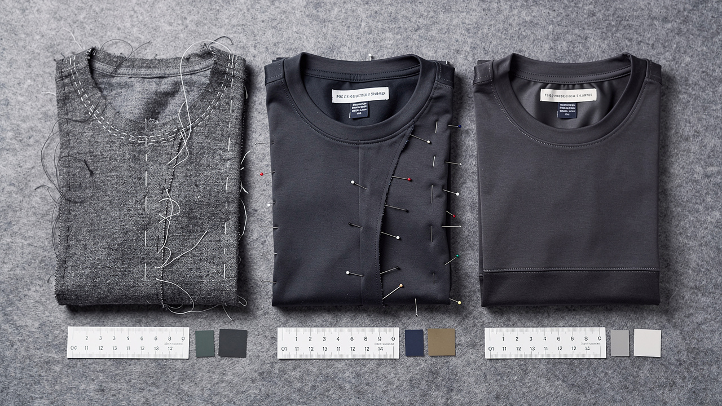
Many brands treat sampling like a box to tick before “real” production. In reality, the sample stages are where a weak custom clothing manufacturer shows up fast. If the fit is off, the fabric feels wrong, or details are sloppy at this stage, bulk will only magnify that.
You will usually see three main sample types.
Sample Type | Purpose | What to Check
Proto Sample | First physical version of your idea. | Overall shape, construction method, and basic fit on a real body.
Fit Sample | Version after first corrections. | Exact measurements, grading across sizes, and seam placement.
Pre-Production Sample | Final standard for bulk. | Final fabric, trims, colors, branding, and packaging details.
Never approve bulk without a signed pre-production sample. This should be the exact fabric quality, print method, and label placement you expect in every carton. Write down any allowed tolerance in measurements or color and share that with the factory so there is no gap in expectations.
Quality control sits on top of this. You will hear the term AQL, which stands for Acceptable Quality Level. For most apparel manufacturing, AQL 2.5 is a common target.
- AQL 2.5 means inspectors accept only a small number of defects in a checked batch. Think of two or three bad pieces out of one hundred as a rough guideline. Ask your factory which AQL level they work to and how they sample cartons. If they cannot answer clearly, they are not taking structured QC seriously.
- Inline inspections happen while garments are still on the sewing floor. Inspectors pull pieces from the line and measure or check stitching right there. This catches pattern, needle, or thread issues before they spread through hundreds of pieces. A plant that only checks at the very end runs a far higher risk of full-batch problems.
When you are qualifying a custom clothing manufacturer, ask directly whether they run inline checks, final checks, or both. Ask who does the inspections and what kind of reports they can share. A partner that controls quality from fabric inwards through finishing is protecting your brand with every order, not just trying to hit a ship date.
Juese Clothing follows this multi-stage approach, checking fabric, cutting panels, sewing work, and finished garments several times before anything leaves the factory. That kind of structure is what keeps your first order and your fifth order at the same standard.
“Quality is made in the factory, not at the inspection table.” – Kaoru Ishikawa

Building a Long-Term Manufacturing Partnership
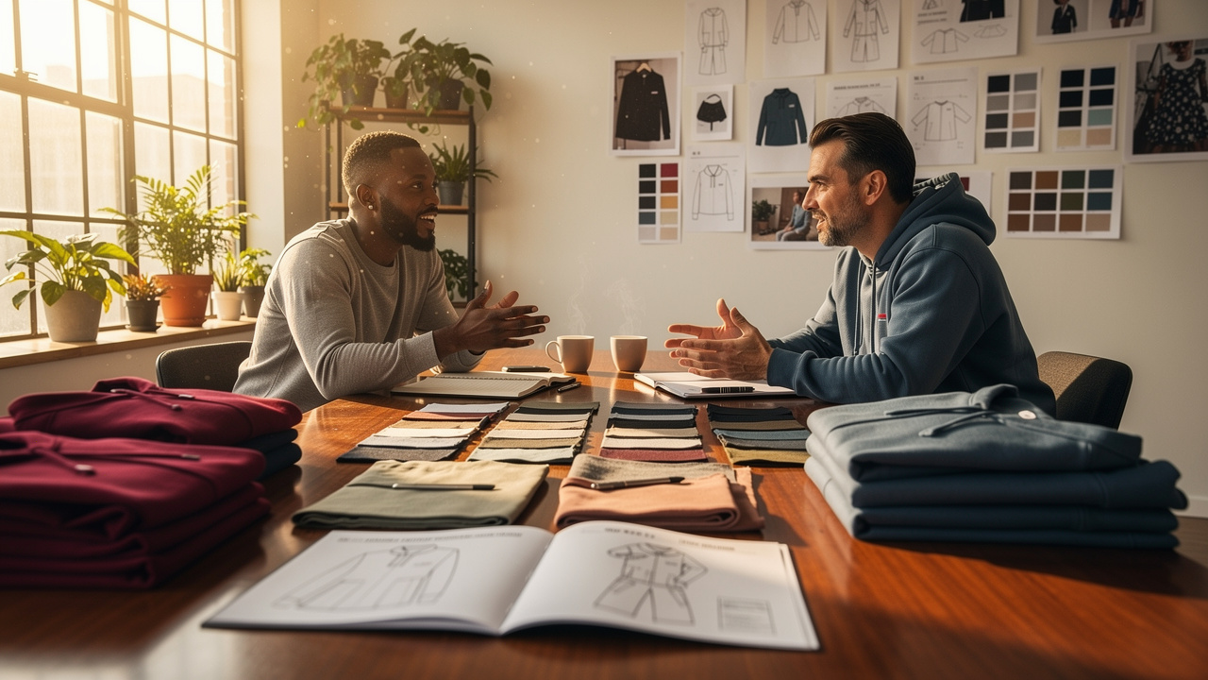
If you treat your factory like a vending machine, you get vending machine service — a particularly costly mistake as the Custom Made Clothes Market continues to expand and brand differentiation increasingly depends on deep, stable manufacturing relationships. The brands that scale do something different. They treat their custom clothing manufacturer as an extension of their own team, especially on planning, risk, and product development.
In a real partnership, your factory warns you when a fabric will be short before it blows your launch. They push back when a design will twist, shrink, or fall apart in real wear. Over time, lead times shrink, not because they cut corners, but because they already know your block patterns, fits, and branding rules.
You can steer things in this direction with some simple habits:
- Share your seasonal calendar early. Map out drops, lookbook dates, and sample deadlines in a simple document. When your manufacturer can see the year, they can reserve fabric and line time around your peak moments.
- Give direct, specific feedback on every sample. Write what works and what does not on fit, feel, and details. Soft comments such as “looks fine” turn into surprises in bulk when the factory assumes everything is perfect.
- Ask for one main point of contact. A stable account manager remembers your past fits, typical issues, and non-negotiables. That person can push internally when you need priority and keep small questions from turning into large mistakes.
Tech pack support is a big signal here. A factory that helps refine your spec sheet, check measurements, and suggest stitching options is not just chasing the next invoice. They are lowering risk on both sides.
Juese Clothing works this way, acting as a one-stop manufacturing partner for OEM and ODM production, private label programs, tech pack support, fabric sourcing, printing and embroidery, strict quality control, and global shipping. You are not forced to juggle several vendors for one style. Their thirty-day money-back guarantee shows they are confident enough in their process to share the risk with you.
“The most dangerous kind of waste is the waste we do not recognize.” – Shigeo Shingo
A steady factory partner helps you spot that waste early, before it reaches your customers.

Conclusion
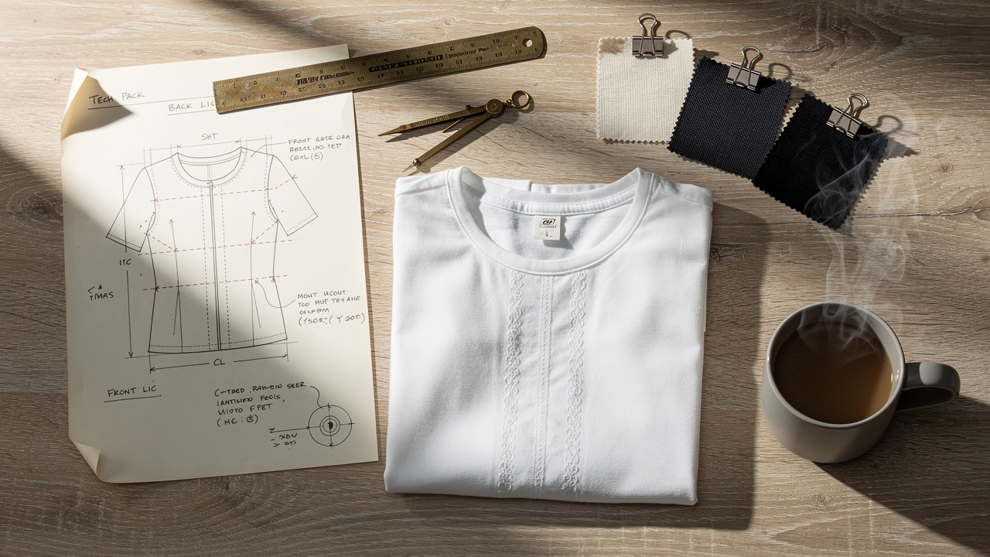
Choosing a factory does not have to feel like gambling. You start by getting honest about what you need: CMT, full package, or private label. You then use the five-pillar scorecard to compare real capabilities, not promises, and you treat sampling and QC as the main test rather than a formality.
The right custom clothing manufacturer is rarely the cheapest or the fastest on a spreadsheet. It is the one whose expertise, compliance, communication, and lead times match where your brand is heading, not just where it sits now. When you treat that factory as a long-term partner, your quality and margins both improve over time.
If you have a tech pack or just a sketch, let's talk. We will give you an honest MOQ assessment — no pressure, no overselling. You can learn more about working with Juese Clothing at jueseclothing.com and see whether our model fits your next collection.

FAQs

What Is the Minimum Order Quantity for Custom Clothing Manufacturing?
Minimum order quantity depends on garment type, fabric, and production model. Private label and simpler items often start at lower units, while complex cut-and-sew pieces can require higher counts. Juese Clothing offers flexible MOQs that let new brands test styles without heavy stock, while still supporting larger runs for growing labels.

What Is the Difference Between OEM and ODM Clothing Manufacturing?
With OEM, you bring the design and specs, and the factory handles apparel manufacturing against that brief. With ODM, the factory develops or co-develops designs, patterns, and sometimes fabrics, and you apply your branding. Early-stage brands often start with ODM support, while more mature labels lean toward OEM once their design direction is stable.

How Long Does It Take to Produce a Custom Clothing Order?
For a well-run custom clothing manufacturer, sampling usually takes around fifteen business days once your tech pack is clear. Bulk production often adds another fifteen to seventeen days after sample approval. That puts a streamlined order at roughly thirty to thirty-five days, with extra transit time if you are shipping overseas. Strong logistics support helps keep the total timeline under control.

What Should You Look For in a Clothing Manufacturer's Quality Control Process?
Look for a factory that builds quality control checks into every stage, not just the final packing line. Ask if they run inline inspections while garments are being sewn and whether they follow an AQL level around 2.5 or better. You want clear inspection reports and photos as proof. Juese Clothing uses this kind of multi-step QC to keep each batch consistent with the approved sample.

